Learning Log
Stage -1
FAFOed meaning of some terms and phrases in the PS like:
- An FNO (Fourier neural operator) is an amortized operator.
- what is meant by "harness"?
- and some more
Stage 0
- Read the 3 research papers concerning each of the methods.
- Revised PDE, ODE and being capable to answer some basic questions like those given in the PS.
- Trained some prototype versions of PINN, FNO and N-ODE. Basic maths and losses which were computed by testing predicted values against exact values (calculated using pytorch and math library).
- Tried to ignore the warning on usage of ReLU in the PS to check what happens. Then used tanh activation. Understood its importance.
Stage 1
- Built the PINN taking motivation from here (this is for 2D heat equation) and here.
- Used adam optimization only.
- Since PINN can be applied to all the problems, used OOP to build classes that sets default properties to application of PINN to each of the problems:
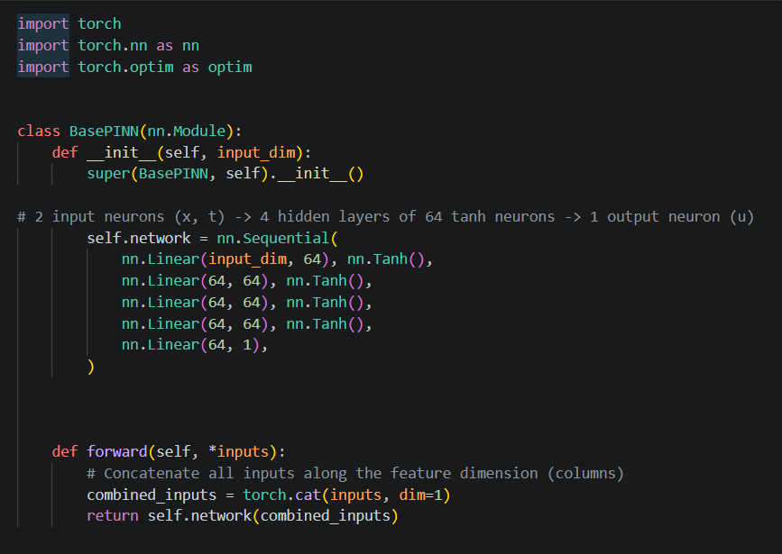

- the results of losses for each of the problems are as follows:
Heat equation
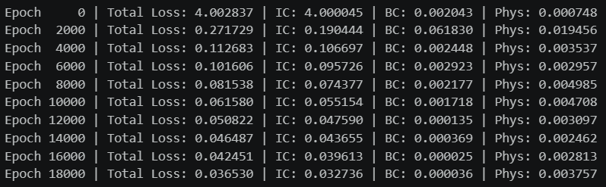

Advection equation
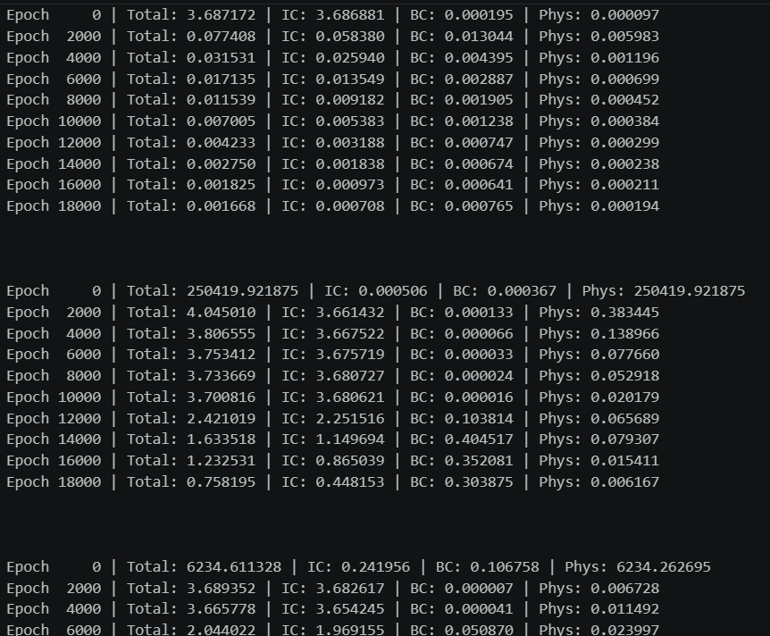

Linear water waves
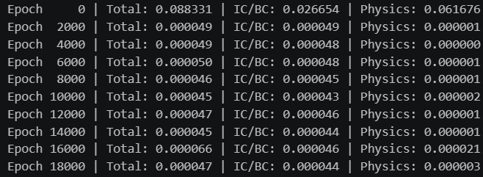

Damped oscillator
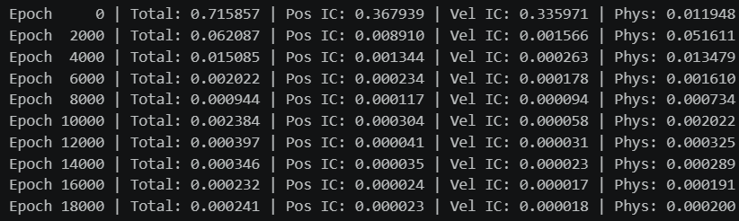

- the neural ode network built shows that even after extrapolation the error is well within limit:
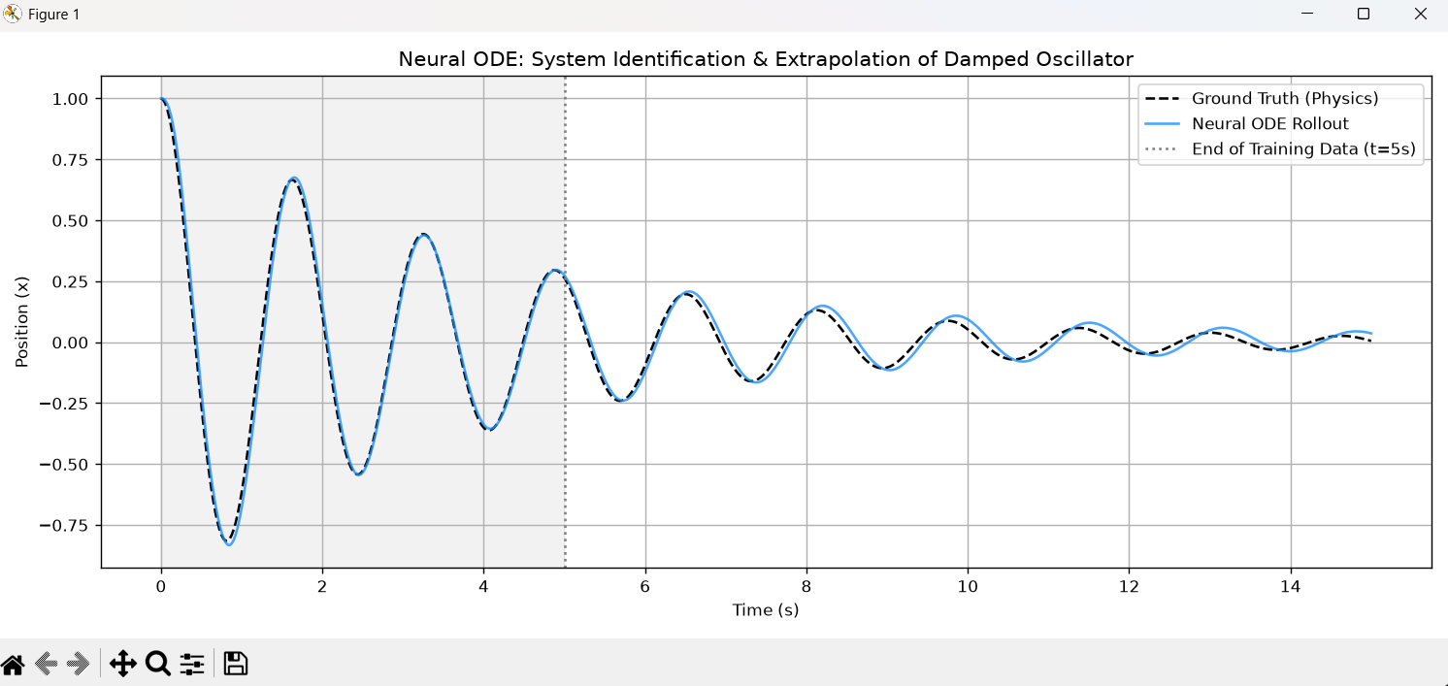
- the plot of this:

is there in the learning log of Aditya (my teammate).

stage 2
- Investigations took up by me from the PS:
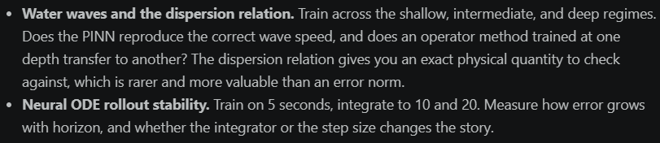
what I inferred from these investigations:
In shallow and intermediate water, the PINN generally nails the wave speed perfectly and has a low L2 error. However as we move into the Deep regime, we see the network fail to converge, and the extracted wave speed will be wildly incorrect.
And the effect of different integrators on the 2nd investigation:
